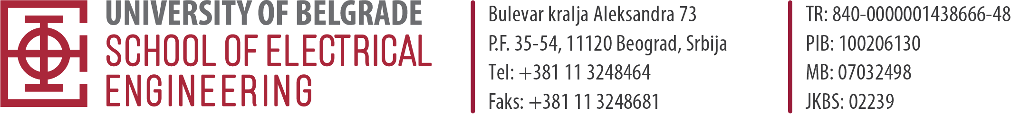
APPLICATION
FOR OPEN COMPETITION FOR ADMISSION TO MASTER ACADEMIC STUDIES
FOR THE SCHOOL YEAR 2024/2025

STUDY PROGRAM: ELECTRICAL ENGINEERING AND COMPUTING
ELECTIVE AREA/MODULE: ______________________________________________________________________
LANGUAGE OF INSTRUCTION: SERBIAN ENGLISH
1. NAME (ONE PARENT’S NAME) SURNAME:
_____________________________________________________________________________

2. GENDER: Male Female

3. Personal ID number:

4. PASSPORT NUMBER FOR FOREIGN CITIZENS: ____________________________

5. DATE, PLACE AND MUNICIPALITY, COUNTRY OF BIRTH: ______________________________________________________________________

6. CITIZENSHIP: Republic of Serbia Foreign citizenship__________________
Nationality: _________________________
7. PLACE OF RESIDENCE: ____________________________________________________
8. PHONE NUMBER (MOBILE): ______________________________________________
9. Е-mail: ___________________________________________________
10. DATA ON UNDERGRADUATE STUDIES:
Faculty _____________________ Study program _______________________
Department _______________________ Year of enrollment _______________
Date of completion of undergraduate academic studies _______________________
Average grade _________________ Final paper grade ___________________
Student’s booklet number (ETF Students Only) ______________________________
11. WERE YOU ENROLLED IN MASTER STUDIES: YES NO
Student’s booklet number from master studies (for ETF students) __________________
Were you financed from the budget for your master's studies: YES NO
12. DID YOU COMPLETE UNDERGRADUATE ACADEMIC STUDIES BY AFFIRMATIVE MEASURES: YES NO
(Only students who previously answered yes should answer the next question)
Are you applying for studies using the affirmative action program?
Student with disabilities Member of the Roma nationality

Candidate signature

______________________________________

