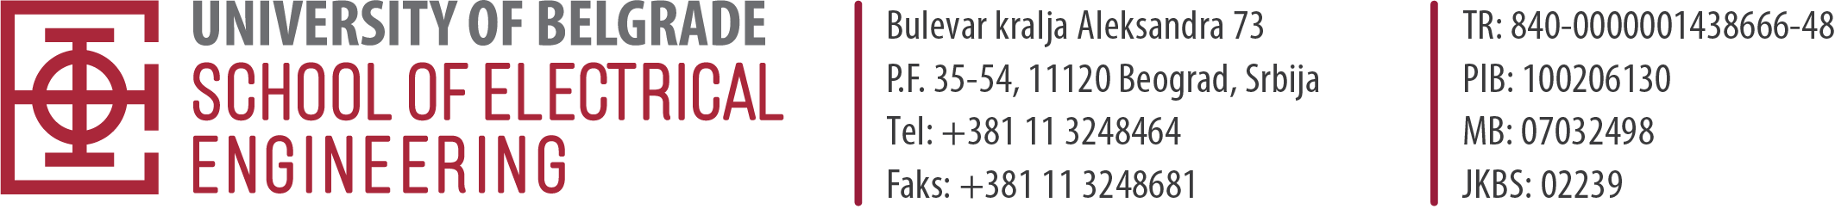
APPLICATION
FOR OPEN COMPETITION FOR ADMISSION TO DOCTORAL ACADEMIC STUDIES

FOR THE SCHOOL YEAR 2024/2025
MODULE: ___________________________________________________________________________
LANGUAGE OF INSTRUCTION: SERBIAN ENGLISH

- NAME, ONE PARENT’S NAME, SURNAME _______________________________________
- GENDER: M/F 3. Personal ID number_____________(passport number for foreign citizens)
- DATE, PLACE AND MUNICIPALITY OF BIRTH _________________________________________
- CITIZENSHIP: ________________________________________ Nationality ___________________
- PLACE OF RESIDENCE ______________________________________________________________
- Phone number (mobile)______________ e-mail _____________________________________________
- INSTITUTION IN WHICH THE CANDIDATE IS EMPLOYED________________________________
- DATA ON PREVIOUSLY COMPLETED STUDIES (Documents should be submitted in addition to this application)
- UNDERGRADUATE STUDIES
Faculty____________________________________ (Student’s booklet number for ETF students)
Department_____________________________________________________________________________
Year of enrollment______ Year of completion____________ Average grade_________________________
Final paper grade________________
б) MASTER STUDIES
Faculty___________________________________ (Student’s booklet number for ETF students)
Module_____________________________________________________________________________
Year of enrollment______ Year of completion____________ Average grade_____________________
Master studies’ final paper grade ________________
- DID YOU HAVE A STATUS OF REST DURING YOUR STUDIES yes/no
- PUBLISHED PAPERS yes/no, (list of references and electronic versions of works category M20-M60 to be submitted when applying for the open competition)
- DO YOU RECEIVE A SCHOLARSHIP yes/no, scholarship type_________________________________
- WERE YOU ENROLLED IN MASTER'S STUDIES: YES / NO (student booklet no. _________)
Candidate signature
- WERE YOU ENROLLED IN DOCTORAL STUDIES: YES / NO (student booklet no. _________)
- WERE YOU ENROLLED IN DOCTORAL STUDIES IN THE STATUS OF BUDGET FUNDING yes / no

